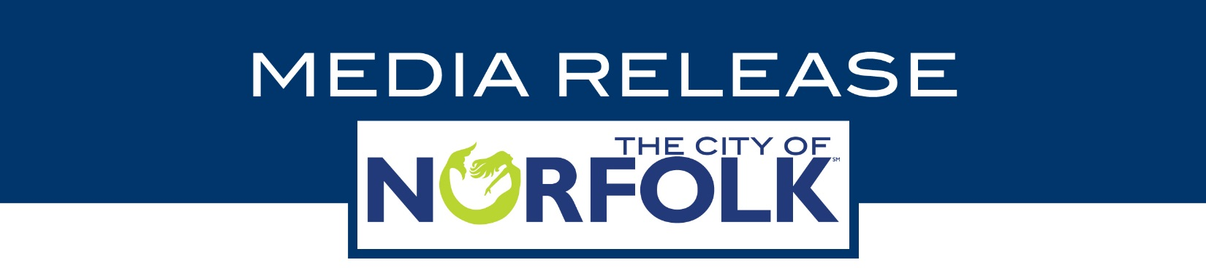

|  |  |  |  |  |  |  |  |  |  |  |  |  |  |
| --- | --- | --- | --- | --- | --- | --- | --- | --- | --- | --- | --- | --- | --- |
| |  |  | | --- | --- | | Contact | Raquel N. Taylor | | Phone | 757-664-7328 ext. 340 | | Mobile | 757-567-3148 | | Email | raquel.taylor@norfolk.gov | | Website | www.norfolkpubliclibrary.org | |  |  | | FOR IMMEDIATE RELEASESeptember 2, 2020 |

super heroe WONDER WOMAN reminds everyone about the power of owning a library card THIS SEPTEMBER!

September 2020

NORFOLK, VA – Every September, Norfolk Public Library (NPL) celebrates the benefits of library card ownership during Library Card Sign-up Month, a national campaign of the American Library Association (ALA) that emphasizes the importance of library cards to a child’s education and to combat illiteracy.

This year, DC’s superhero Wonder Woman has been chosen by ALA as the Honorary Chair to champion the power of owning a library card. Wonder Woman is a founding member of the Justice League, and is known for her compassion, strength and truth. “Armed with the Lasso of Truth,” she makes for the perfect ambassador to support Library Card Sign-up Month according to ALA.

Now that millions of jobs have been lost in America and homeschooling children is the norm, we are reminded there is nothing more empowering than having library card. It gives you access to technology, free resources, virtual programs and services to pursue your passions and dreams.

NPL’s digital collection is available 24/7 at <http://bit.ly/NPLBooksMore>. Browse, sample, place holds and download movies, eBooks, eAudiobooks, and music directly to your computer or digital device. You can also access the more than 90 databases to read American newspapers, find information about global issues, get assistance with building a resume, learn more than 80 foreign languages, and much more for free with your Norfolk Public Library card.

NPL’s digital collection is free for Norfolk residents, Norfolk property owners, Norfolk business owners, and those who are employed in Norfolk. Other Virginia residents can access the digital collection for an annual fee of $35.00.

Norfolk Public Library cardholders also have access to Grab-n-go service at the Jordan-Newby Anchor Branch Library, Pretlow Anchor Branch Library, and the Slover Library. With Grab-n-Go service, patrons may enter the lobby area to pick up holds, check out materials, apply for or renew a library card, and get help with questions.

Sign up for a library card and find something wonderful at Norfolk Public Library! Visit [www.norfolkpubliclibrary.org](http://www.norfolkpubliclibrary.org) for more information.

**About Norfolk Public Library:**

The Norfolk Public Library offers access to information, books, programs, and online resources to meet the needs of our diverse community for life-long learning. The library system consists of two anchor branch libraries, ten branch libraries and a Bookmobile. All programs are FREE of charge. Visit [www.norfolkpubliclibrary.org](http://www.norfolkpubliclibrary.org) or call us at 757-664-READ for more information.

*NPL- Creating a City of Readers.*

# # #